Git
Day 3 - 21th May 2025
Task 1:

Recap of Last session:

Create a file named 21st May.txt and push it to your git hub.
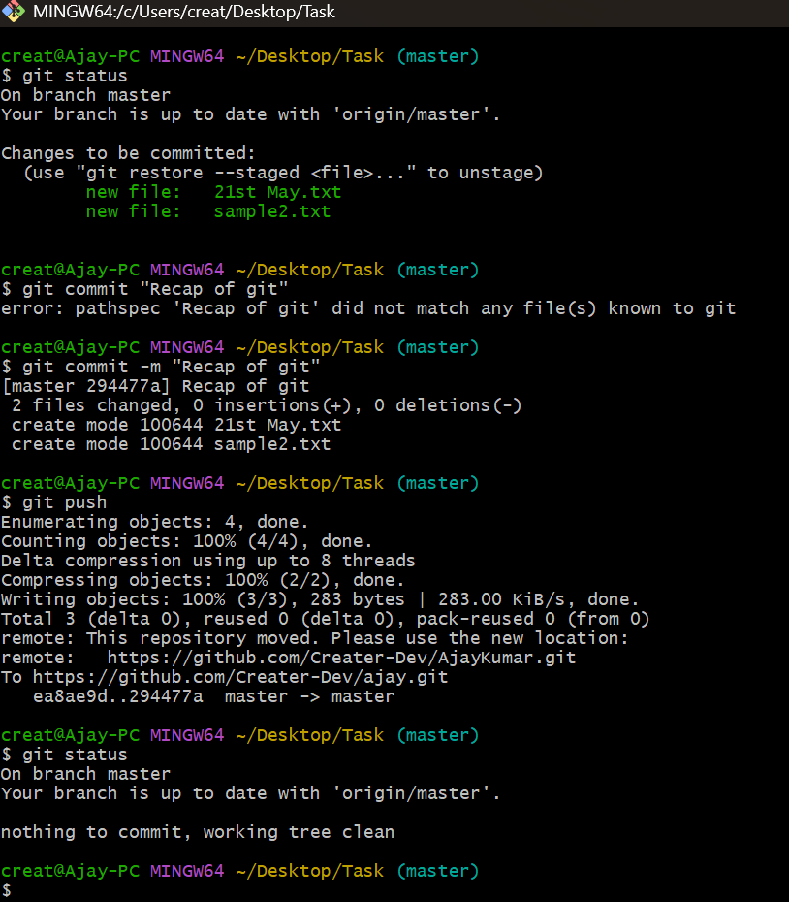
Git hub screenshot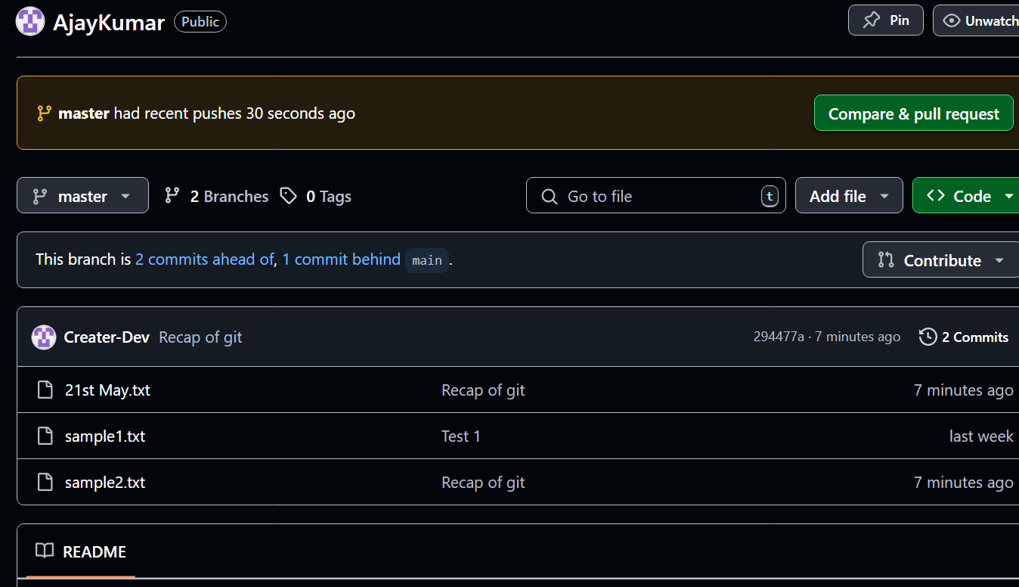
Task 2:
Git log

Git show

Git branch - list all the branches

Git branch PrasunambaBranch - create a new branch

Git branch

Git checkout targetbranch name

Git checkout PrasunambaBranch (this will switch the branch)

If i want to merge PrasunambaBranch to master branch

Git checkout master
(first move to the target branch)

Git merge PrasunambaBranch

(merger PrasunambaBranch to master branch
Home Task:

git stash :
Git stash is a command used to temporarily store changes that are not ready to be committed to the repository. It’s helpful when you want to switch branches, but you don’t want to commit your changes or lose them. Stashing allows you to save your work in progress and come back to it later.
When you run “git stash”, Git will:
- Take all the changes in your working directory and index (staging area) and save them as a “stash”.
- Reset your working directory and index to the last commit, effectively removing the changes from view.
- You can later apply the stashed changes back to your working directory using “git stash apply” or “git stash pop” commands.
It’s a convenient way to manage your work-in-progress changes without cluttering your commit history or losing any work.
Important Command for git stash :
# To stash an item
git stash
# To see the stashed items list
git stash list
# To apply stashed items
git stash apply stash@{number}
# To clear the stash item
git stash clear

git reset :
Git reset is a command used to undo changes in your working directory to staging area.
git reset <file name>
or
git reset .
See the workflow of git reset :
Git reset and git revert
Git reset – unstage (after add u can unstage)
Add X reset
Git revert - uncommit (after commit )
Commit X revert
Removing Untracked File :
git clean -n #(ask for delete yes or no)
git clean -f #(forcefully)
Tags :
It is used to gives meaningful names to a specific version in the repository.
git tag -a <tag name> -m <message> <commit-id>
# To see the list of tags
git tag
# To see particular commit content by using tag
git show <tag name>
# To delete a tag
git tag -d <tag name>

Database:
What is a Database?
A database is like a big notebook where we store information neatly so we can find it later. It helps keep things organized, like a list of friends' phone numbers or a record of all the books in a library.
A database is a place where data is stored and organized so it can be easily accessed, managed, and updated. Think of it like a digital filing cabinet where information is neatly arranged for quick retrieval.
Examples:
- A library database holds book records.
- A bank database keeps track of customer accounts.
- A website database stores user profiles and posts
What is Data?
Data is simply information that is collected, stored, and used for various purposes. It can be anything—numbers, words, images, or even sounds. For example, your name, age, and phone number are pieces of data.
Computers and databases store and process data to make it useful, helping businesses, websites, and apps function efficiently.
list of different types of data:
1. Based on Structure
- Structured Data – Organized in tables (e.g., databases).
- Unstructured Data – No fixed format (e.g., images, videos).
- Semi-Structured Data – Mix of structured and unstructured (e.g., XML, JSON).
2. Based on Origin
- Raw Data – Unprocessed information.
- Processed Data – Organized and analyzed data.
- Derived Data – Data created from existing datasets.
3. Based on Functionality
- Metadata – Data about other data (e.g., file details).
- Transactional Data – Related to business transactions.
- Operational Data – Used in day-to-day activities.
4. Based on Storage
- Big Data – Large-scale data requiring special processing.
- Streaming Data – Real-time data flow.
- Time-Series Data – Data collected over time (e.g., sensor readings).
5. Based on Format
- Text Data – Words, documents.
- Numerical Data – Numbers, statistics.
- Multimedia Data – Images, audio, video.
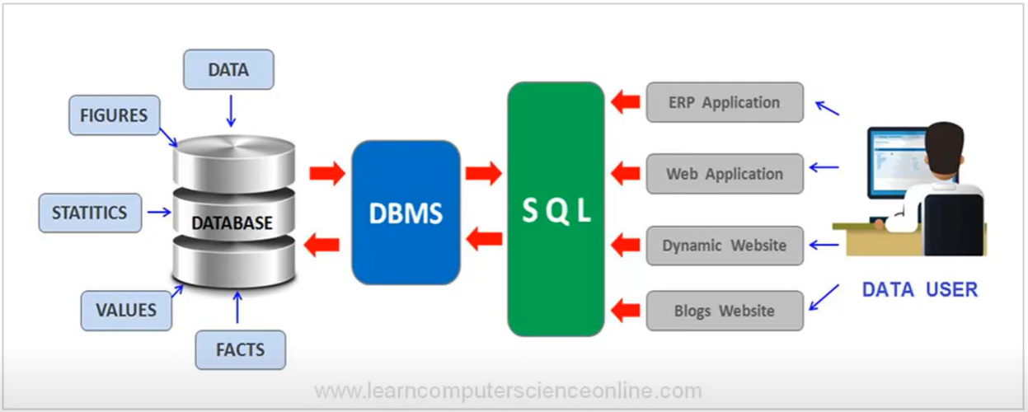
Types of Databases:
Databases come in different types, depending on how they store and manage data. Here are the main types:
- Relational Databases (RDBMS) – Store data in tables with rows and columns (e.g., MySQL, PostgreSQL, SQL Server).
- NoSQL Databases – Handle unstructured or semi-structured data using different models like key-value, document, or graph (e.g., MongoDB, Cassandra).
- Cloud Databases – Hosted on cloud platforms for scalability and accessibility (e.g., AWS RDS, Google Cloud Firestore).
- Distributed Databases – Spread across multiple servers or locations to improve performance and fault tolerance.
- Graph Databases – Store relationships between entities in a graph structure for fast relational queries (e.g., Neo4j).
- Time-Series Databases – Optimized for tracking time-based data like IoT sensors or stock prices (e.g., InfluxDB).
- In-Memory Databases – Store data in memory for fast retrieval (e.g., Redis).
- Hierarchical Databases – Organize data in a tree-like structure, common in legacy systems.
- Object-Oriented Databases – Store data as objects similar to programming concepts.
Definitions of ACID propreties:
ACID stands for Atomicity, Consistency, Isolation, and Durability. It’s a way to describe how a database transaction should work reliably:
- Atomicity:
Think of it as an "all-or-nothing" rule. For example, when you transfer money from your bank account to a friend’s account, either the money is both deducted from your account and added to theirs, or nothing happens at all—not one step without the other.
- Consistency(Correctness of the Data):
This ensures that every transaction keeps everything in balance with the rules. Imagine a rule where your bank account should never go negative; if you try to withdraw more than you have, the system won’t let the transaction go through.
- Isolation:
Even if multiple people are doing transactions at the same time (like two friends withdrawing money at an ATM), each transaction happens separately without interfering with one another. Each person sees the account in a stable, unchanging state until their transaction is fully completed.
- Durability(Consistent throughout):
Once a transaction is complete, it is permanently saved. For instance, after you deposit money and get a confirmation, the deposit remains recorded—even if the bank's system crashes right afterward, your deposit is still safe.
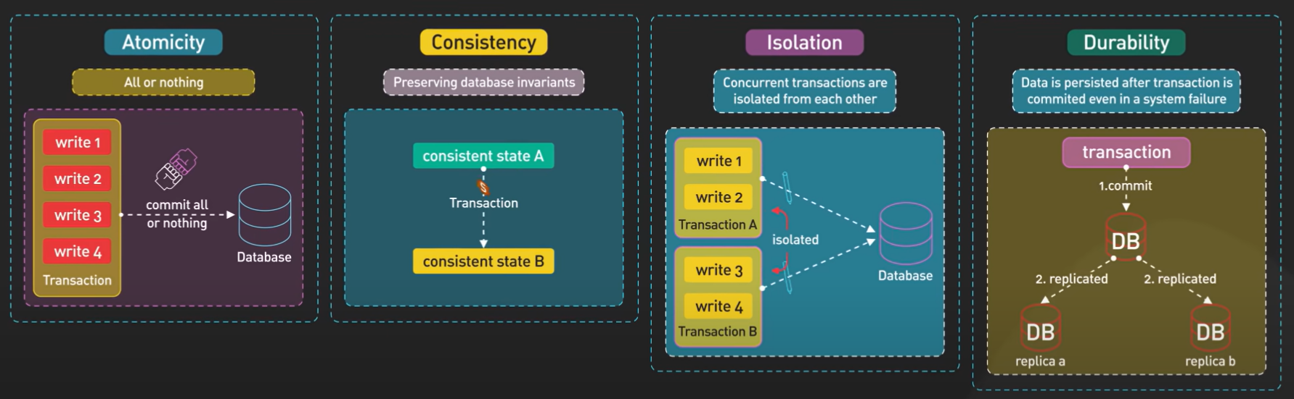
Difference between relational and non relational database:
Relational Database: A relational database stores data in neatly organized tables with rows and columns, similar to a spreadsheet. Examples: MySQL, PostgreSQL, Oracle.
- Everyday Example:
Think of a class attendance sheet where every student’s name, grade, and roll number are always listed in the same order. Every entry has the same categories—you can easily look up any student's details because the format always stays the same.
Non-Relational Database: A non-relational database (often called NoSQL) stores data in a more flexible format where rows and columns aren’t required.
Examples: MongoDB, Redis, Cassandra.
- Non-Relational Example:
Now imagine a collection of postcards where each postcard has different drawings, messages, and stamps. There is no strict rule about what each postcard must have. You might have one with a drawing and a handwritten note, another with a printed message and no drawing, and so on. This flexibility lets you store lots of different kinds of information in one place.
Properties of Relational Database:
- A relational database is a collection of relations.
- The database tables have a row column format.
- Operators are available either to join or separate columns of the database table.
- Relations are formed with respect to data only.
- The tables can be accessed by using simple non-procedural statements.
- The data is fully independent, that is it will be the same irrespective of the access path used.
Salient features of the relational model:
- Conceptually simple: the fundamentals are intuitive and easy to pick up.
- Powerful underlying theory: the relational model is the only database model that is powered by formal mathematics, which results in excellent dividends when developing database algorithms and techniques.
- Easy-to-use database language: though not formally part of the relational model, part of its success is due to SQL, the default language for working with relational databases.

list of commonly used terms and terminologies in databases:
- Data:
Raw facts or pieces of information (e.g., numbers, words). Database:
An organized collection of data stored for efficient retrieval and management.
- DBMS (Database Management System):
Software that helps you create, manage, and query databases (like MySQL or Oracle).
- Table (or Relation):
A structure that holds data in rows and columns, similar to a spreadsheet.
- Row (Record or Tuple):
A single record in a table that contains related pieces of data (for example, one student's information in a student table).
- Column (Field or Attribute):
A specific category of data within a table (like “Name,” “Age,” or “Grade”).
- Primary Key:
A unique identifier for each row in a table, ensuring that every record can be uniquely distinguished (like a student ID).
- Foreign Key:
A field in one table that links to the primary key in another table, creating a relationship between the two tables.
- Schema:
The blueprint of a database that outlines how data is organized (the structure of tables, fields, and relationships).
- Query:
A request for information from the database, typically written in a language like SQL. For example, “Find all students in class 10.”
- Index:
A data structure that speeds up the search for records in a table—similar to an index at the back of a book.
- Transaction:
A sequence of operations performed as a single, indivisible unit. It’s "all or nothing," meaning if one part fails, the entire transaction fails.
- ACID Properties:
Characteristics that ensure reliable transaction processing:
  - Atomicity: Everything in the transaction happens or nothing does.
  - Consistency: The database remains in a valid state before and after the transaction.
  - Isolation: Transactions do not interfere with each other.
  - Durability: Once committed, transactions are permanently recorded.
- Normalization:
The process of organizing data to reduce redundancy and improve data integrity.
- Join:
An operation that combines rows from two or more tables based on a related column.
- View:
A virtual table based on a SELECT query, which lets you see data from one or more tables without storing it separately.
- Trigger:
A set of instructions that automatically execute in response to certain events in a table, such as inserting or updating records.
- Stored Procedure:
A pre-written set of SQL statements stored in the database that can be executed repeatedly to perform common tasks.

RDBMS Doc 4.pdf
https://drive.google.com/file/d/1cgSZ6wmPmFbx-tC78lt6zC9UBYiDJlyP/view?usp=sharing

NOSQL Doc 5 pdf

https://drive.google.com/file/d/1PDqGKE766Z-rG4GVh3ycwJyrraiJV-my/view?usp=sharing

MongoDb Installation link

https://www.mongodb.com/try/download/community

MongoDb installation steps link

https://www.mongodb.com/docs/manual/tutorial/install-mongodb-on-windows/

this is also MongoDb link any one you can follow..

https://www.geeksforgeeks.org/how-to-install-mongodb-on-windows/

Mongosh installation steps link

https://www.mongodb.com/docs/mongodb-shell/install/

Setting the path..

Env path

C:\Program Files\MongoDB\Server\7.0\bin

C:\Program Files\MongoDB\mongosh\mongosh-2.2.12-win32-x64\bin

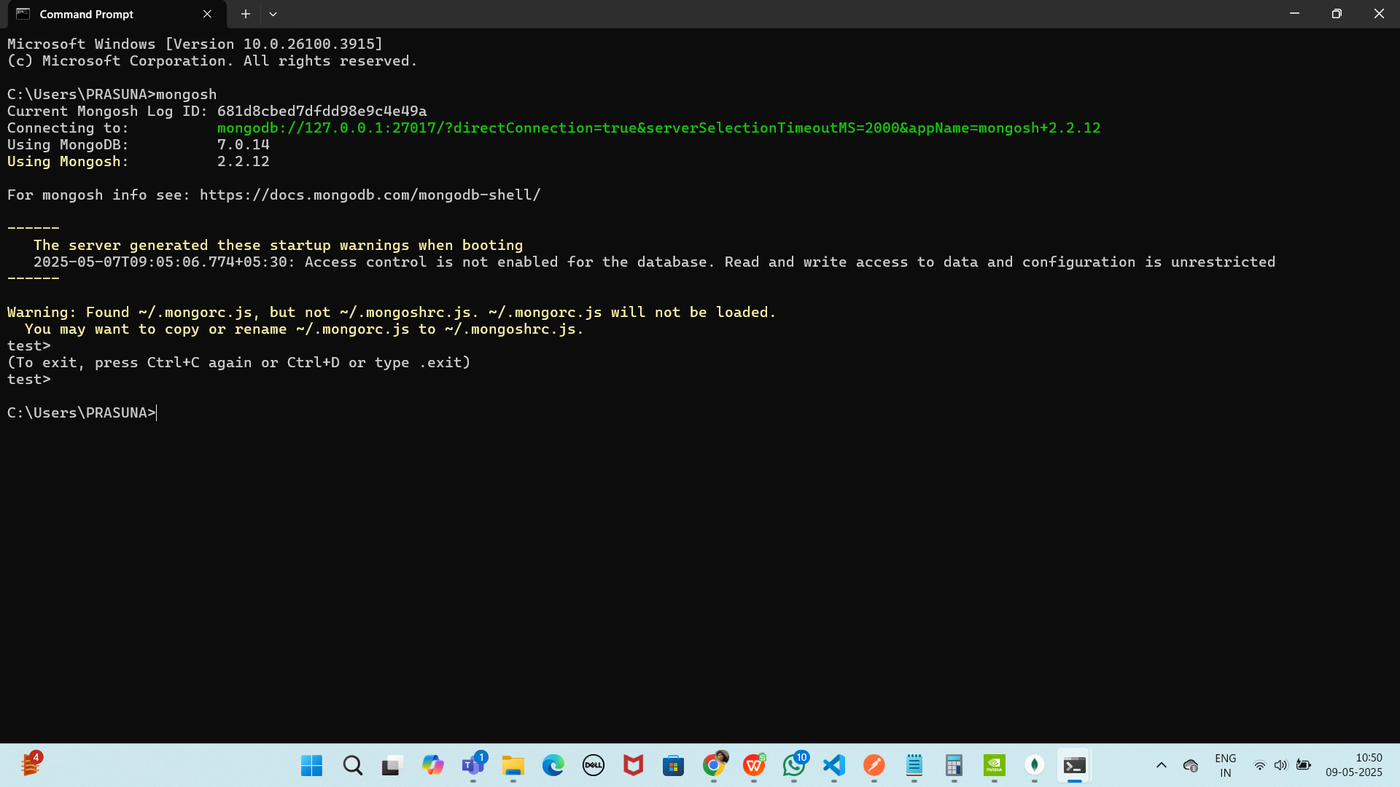

mongo db compass

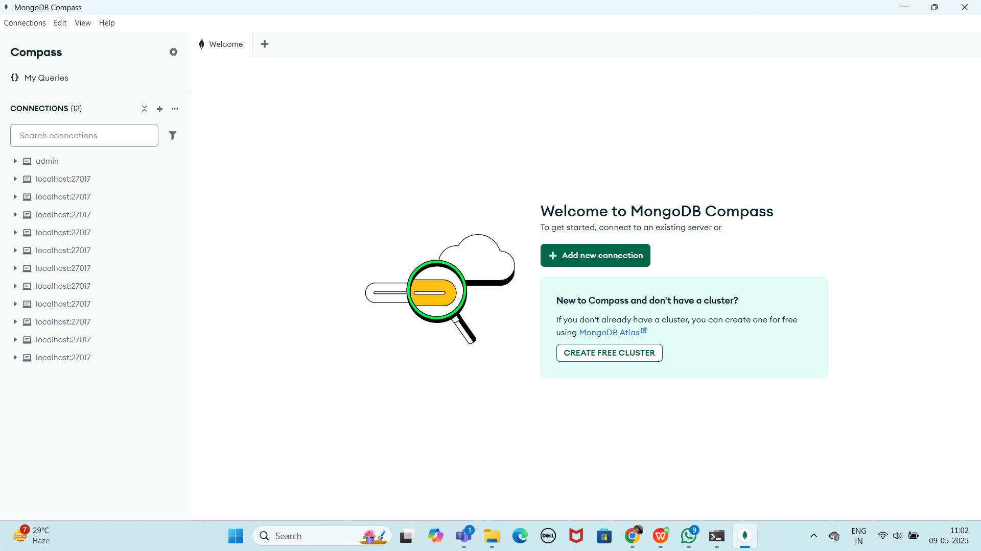

Make sure 2 cmd s are open

- Cmd - mongod
- Cmd - mongosh

Create a database

Use Blog (this is my database)

Remember: In MongoDB, a database is not actually created until it gets content!
Collection using mongosh
Commands:
db.createCollection(“posts”)

db.posts.insertOne({“title”: “1st Post”})
Output:
Blog> db.posts.insertOne({"title":"my 1st post"})
{
acknowledged: true,
insertedId: ObjectId('682da63fae74a79c09c4e49b')
}

Remember: In MongoDB, a collection is not actually created until it gets content!

Inserting documents

insertOne()

Input:
Blog> db.posts.insertOne([
{
... title: "Post Title 1",
... body: "Body of post.",
... category: "Sports",
... likes: 1,
... tags: ["news", "Sports"],
... date: Date()
... })
Output:
{
acknowledged: true,
insertedId: ObjectId('682da717ae74a79c09c4e49c')
}

Plz Note: If you try to insert documents into a collection that does not exist, MongoDB will create the collection automatically.

Find the data:
Input:
Blog> db.posts.find()
Output:
[
{ _id: ObjectId('682da63fae74a79c09c4e49b'), title: 'my 1st post' },
{
_id: ObjectId('682da717ae74a79c09c4e49c'),
title: 'Post Title 1',
body: 'Body of post.',
category: 'News',
likes: 1,
tags: [ 'news', 'events' ],
date: 'Wed May 21 2025 15:42:39 GMT+0530 (India Standard Time)'
}
]
Input:
db.posts.findOne()
Give object to fetch
Querying Data:
Input:
Blog> db.posts.findOne('my 1st post')
MongoInvalidArgumentError: Query filter must be a plain object or ObjectId
Blog> db.posts.find({category:"News"})
Output:
[
{
_id: ObjectId('682da717ae74a79c09c4e49c'),
title: 'Post Title 1',
body: 'Body of post.',
category: 'News',
likes: 1,
tags: [ 'news', 'events' ],
date: 'Wed May 21 2025 15:42:39 GMT+0530 (India Standard Time)'
}
]

Projection:
Both find methods accept a second parameter called projection.
This parameter is an object that describes which fields to include in the results.
Note: This parameter is optional. If omitted, all fields will be included in the results.
Input:
Blog> db.posts.find({}, {title: 1, date: 1})
Output:
[
{ _id: ObjectId('682da63fae74a79c09c4e49b'), title: 'my 1st post' },
{
_id: ObjectId('682da717ae74a79c09c4e49c'),
title: 'Post Title 1',
date: 'Wed May 21 2025 15:42:39 GMT+0530 (India Standard Time)'
}
]

Have you noticed that the _id field is also included. This field is always included unless specifically excluded.
We use a 1 to include a field and 0 to exclude a field.
Input:
Blog> db.posts.find({}, {_id: 0, title: 1, date: 1})
Output:
[
{ title: 'my 1st post' },
{
title: 'Post Title 1',
date: 'Wed May 21 2025 15:42:39 GMT+0530 (India Standard Time)'
}
]

Update a Document
Input:
Blog> db.posts.updateOne( { title: "Post Title 1" }, { $set: { likes: 20 } } )
Output:
{
acknowledged: true,
insertedId: null,
matchedCount: 1,
modifiedCount: 1,
upsertedCount: 0
}
Try doing the updateMany command also..
Upsert – will update if found and insert if the doc not found
Input:
Blog> db.posts.updateOne(
... { title: "Post Title 3" },
... {
... $set:
... {
... title: "Post Title 3",
... body: "Body of post.",
... category: "Sports",
... likes: 50,
... tags: ["news", "Sports"],
... date: Date()
... }
... },
... { upsert: true }
... )
Output:
{
acknowledged: true,
insertedId: ObjectId('682daec91cac9dbc5ac4a079'),
matchedCount: 0,
modifiedCount: 0,
upsertedCount: 1
}
You try updatemany also
TRy delete to delete a doc
db.posts.deleteOne({ title: "Post Title 5" })
Try delete many also

